EFR32 106 – TYPE WATER PRESSURE (NG)

### 

### Key Functionalities of the EFR32 106 Water Pressure Monitoring System

1. **Wake-Up and Sampling**: The system wakes up every minute to sample the water pressure using an I2C sensor. This regular sampling is crucial for real-time monitoring of water pressure levels.
2. **Explosive Messages on Activity**: Whenever there is an activity such as the start or stop of irrigation, the system sends an immediate explosive message. This feature ensures prompt communication of significant events.
3. **Hourly Updates**: After 60 samples (60 minutes), the system sends an hourly message. This routine reporting provides a consistent update on the water pressure status over time.
4. **Post-Activity Sleep Mode**: Following the recording of a measurement value, the sensor immediately returns to sleep mode. Similarly, after sending a burst message and receiving an acknowledgment (ACK) message, the system promptly re-enters sleep mode. This approach helps conserve energy.
5. **Retransmission on Missing ACK**: If the sensor does not receive an ACK within 500 milliseconds, it retries the message up to four times. This mechanism ensures reliability in message delivery despite potential communication interruptions.
6. **Energy Efficiency and Consumption Metrics**
7. **Energy Mode (EM4):** The system has a low energy consumption of 3.6uA in shutoff mode (EM4), contributing to its efficiency.
8. **Sampling Energy Consumption**: During sampling, the system consumes 2.16mA over a duration of 132ms. This higher consumption is due to the active operation of the sensor.
9. **Average Current Consumption**: The system has an average current consumption of 12.50uA.
10. **Average Power Consumption**: The average power consumption is calculated to be 39.67uW.
11. **Total Energy Consumption for 23787.70 seconds**: The average energy consumption is 262.48uWh.

* In summary, the EFR32 (106) – TYPE_WATER_PRESSURE (NG) system is designed for efficient and periodic monitoring of water pressure, with an emphasis on energy conservation. The system's functionality includes regular water pressure sampling, immediate response to irrigation activities, hourly updates, and efficient energy management, particularly in its EM4 energy mode. The retransmission strategy in case of missing ACKs enhances the system's reliability in communication.

### Board

### 

### Time Period

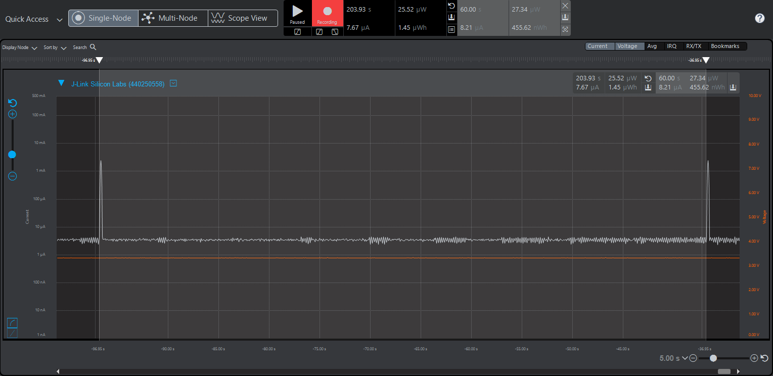

### Measuring Moment

### Delta Time Calculations and conclusions

| Wake-Up Event | Timestamp | Time Since Last Wake-Up (Delta) | Cumulative Delta Time |
| --- | --- | --- | --- |
| 2 | 2023-11-12 16:54:11.791 | 60.043 seconds | 60.043 seconds |
| 3 | 2023-11-12 16:55:11.833 | 60.042 seconds | 120.085 seconds |
| 4 | 2023-11-12 16:56:11.871 | 60.038 seconds | 180.123 seconds |
| 5 | 2023-11-12 16:57:11.903 | 60.032 seconds | 240.155 seconds |
| 6 | 2023-11-12 16:58:11.955 | 60.052 seconds | 300.207 seconds |
| 7 | 2023-11-12 16:59:11.983 | 60.028 seconds | 360.235 seconds |
| 8 | 2023-11-12 17:00:12.007 | 60.024 seconds | 420.259 seconds |
| 9 | 2023-11-12 17:01:12.056 | 60.049 seconds | 480.308 seconds |
| 10 | 2023-11-12 17:02:12.091 | 60.035 seconds | 540.343 seconds |
| 11 | 2023-11-12 17:03:12.116 | 60.025 seconds | 600.368 seconds |
| 12 | 2023-11-12 17:04:12.169 | 60.053 seconds | 660.421 seconds |
| 13 | 2023-11-12 17:05:12.204 | 60.035 seconds | 720.456 seconds |
| 14 | 2023-11-12 17:06:12.244 | 60.040 seconds | 780.496 seconds |
| 15 | 2023-11-12 17:07:12.279 | 60.035 seconds | 840.531 seconds |
| 16 | 2023-11-12 17:08:12.308 | 60.029 seconds | 900.560 seconds |
| 17 | 2023-11-12 17:09:12.337 | 60.029 seconds | 960.589 seconds |

Based on the data provided in the timing table, several important conclusions can be drawn:

Using the ULFRCO clock is the most efficient in terms of energy saving, but as can be seen from the table, we pay in tolerances.

There is a cumulative error in the wake-up times. This could lead to deviations from the planned time for each activity (slot) of the system. Therefore, an offset correction is necessary. Even using a more accurate clock like the LFXO will get out of sync over time and will lose its slot without offset correction, so there is no obstacle to calibrating the sensors by the 'master'.

Also, the master unit (Logger / CCU) will get out of sync over time and needs to 'take' the sensors with it, if we want to be precise, we can use an atomic clock (GPS).

### EM4 - Lowest Power Energy Mode

1. **Explosive Message**

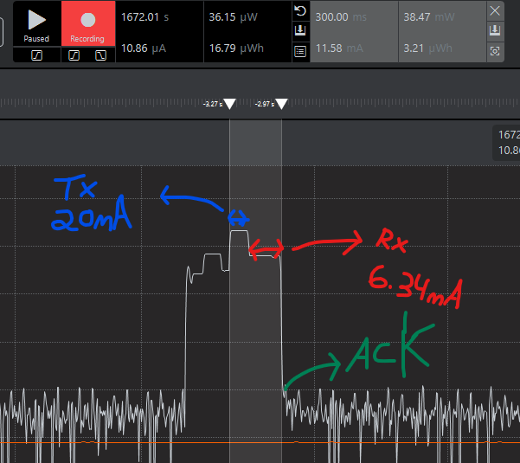

**9. Hourly Message**

## 

1. **Battery Lifetime Calculations**

* EFR32FG23 MCU:
  + 1.71 V to 3.8 V single power supply
  + -40 °C to +125 °C

Average Current Draw in mA:

Battery Capacity in mAh:

Battery Capacity in mAh:

Hours in a Year:

Battery Life in Years:

69 years

**Note**: The current consumption provided from the Energy Profiler of Simplicity Studio, which is Silicon Labs' IDE.